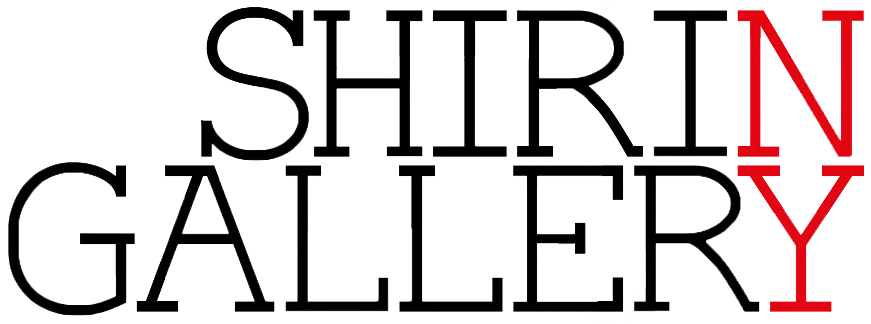
SHIRIN GALLERY AT SCOPE NYC 2014
March 7–9, 2014

Booth E19
SCOPE PAVILION
312 West 33rd Street
New York, 10001
USA

Platinum VIP Preview Gala: Thurs, March 6, 3–6pm
First View Benefit & Press: Thurs, March 6, 6–9pm

Open Hours:
Fri, March 7, 11am–8pm
Sat, March 8, 11am–8pm
Sun, March 9, 11am–7pm

Shirin Gallery is pleased to present works by Safaeddin Emami, Hadi Hazavei, Hedieh Javanshir Ilchi, Amirnasr Kamgooyan, Hamed Noori, Mitra Arbab Saljoughi, Hiba Schahbaz, Atoosa Vahdani, and Shadi Yousefian at SCOPE NYC 2014.

Shirin Gallery will be exhibiting at Booth E19 between Friday, March 7 and Sunday, March 9. For fair directions and hours please see the SCOPE website. For all sales-related and other inquires, please contact the gallery at info@shiringalleryny.com.

EXHIBITING ARTISTS:

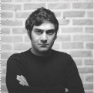
Safaeddin Emami was born in 1981 in Tehran (IR) and received his B.A. in graphic design from Sooreh University. He has been a member of the Society of Iranian Graphic Artists since 2004. His practice colludes history and popular culture to inflect contemporary social and political conflicts with speculative whimsy—what if American superhero figures were present in the historic battles of medieval Persia? Verging on the absurd, Emami reframes our perceptions of power, force, and agency.

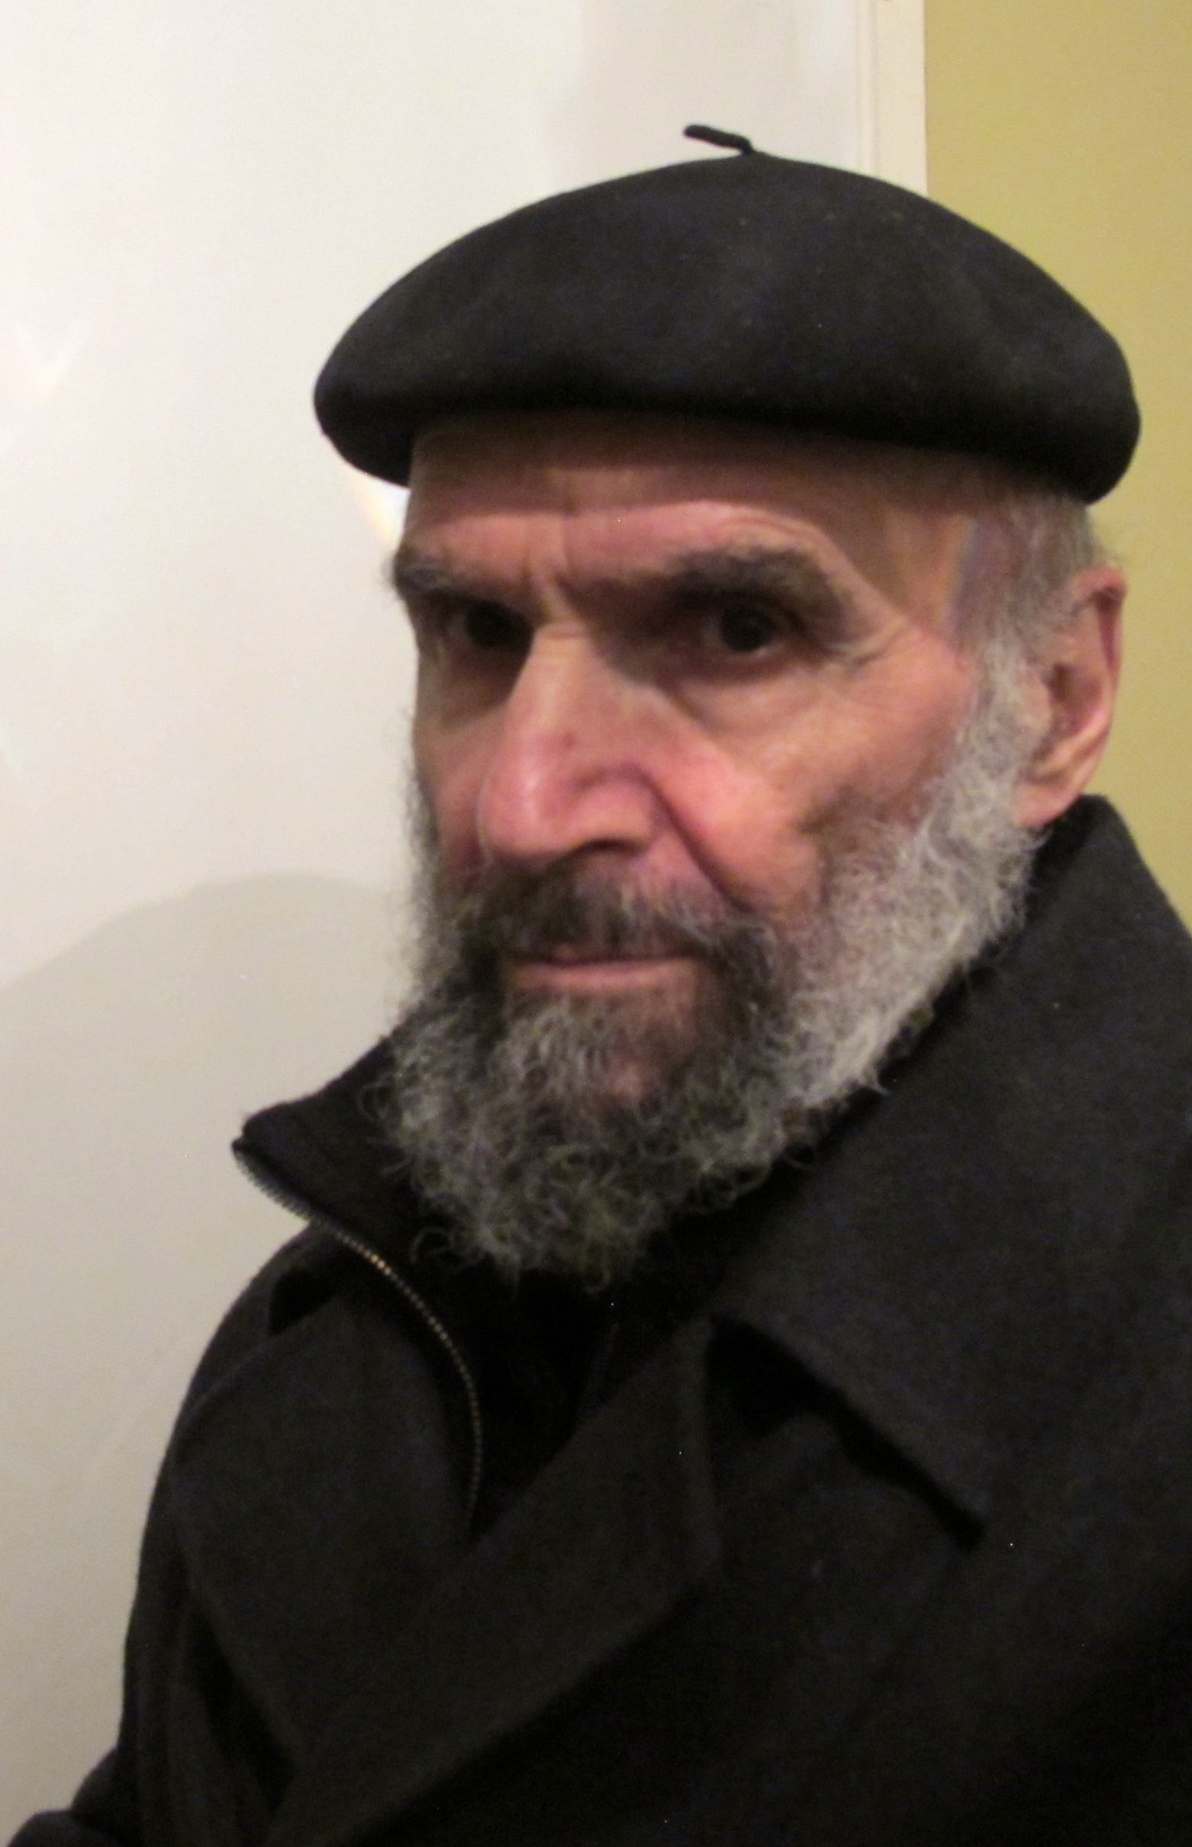
Hadi Hazavei (Arak, IR) is an artist and educator whose practice engages media and aesthetic traditions as diverse as Persian calligraphy, carpet-weaving, and folk art to Euro-American Abstract Expressionism. Hazavei received his BFA in painting from the University of Tehran in 1968; his MFA in painting from the City College of New York in 1971; and his PhD in Art Education at Columbia University in 1975. Hazavei has served as Head of Art Education at Tehran’s Negarestan Museum between 1977–78 and conducted post-doctoral research in Museum Studies at New York University until 1989. He has authored numerous books on art and education; exhibited work and organized exhibitions internationally; and produced numerous murals.

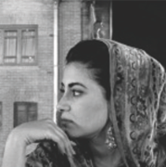
Hedieh Javanshir Illchi was born in Tehran (IR) and lives and works in Washington, D.C. She received her BFA from the Corcoran College of Art & Design in 2006 and her MFA in Studio Art from American University in 2011. Her artistic practice is motivated by the ambivalence of her identity as an Iranian-American. Recent paintings reflect her continued investigation into the intersections of western abstraction and traditional Persian art. The syntheses of these visual codes evoke allegories of intrusion and invasion, referencing historical and contemporary sociopolitical conflicts alike.

Amirnasr Kamgooyan was born in 1981 in Tehran (IR) and received his BA in graphic design from Shiraz Soure University. He has exhibited works widely throughout Tehran and art fairs internationally. Wielding conventions of graphic design as a dynamic visual language, Kamgooyan explores themes of power and ideology manifest in the transformations born of modernity.

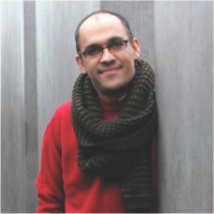
Hamed Noori was born in 1979 in Mashhad (IR) and received his BA from Kashan University, Faculty of Arts and Architecture in 2007. He is a former graduate student of ‘Art in Context’ at Berlin University of the Arts. His practice is concerned with incongruity and contradiction in a range of cultural and historical contexts, specifically his own in Iran. His works emerge where personal experience intersects with social and historical reality, revealing frameworks of collective identity within the intimacy of an individual’s biography.
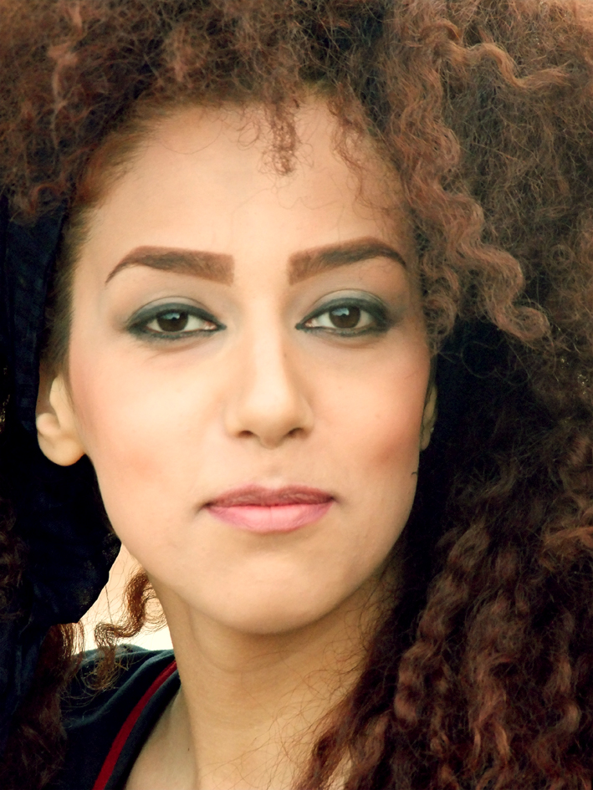
Mitra Arbab Saljooghi (1990, Mashhad IR) was educated as a graphic designer in Iran, where she currently lives and practices. Her works investigate the complex interactions between environmental, social, and technological processess, using scultptural form inspired by her formal training in design. Salijooghi’s work has been exhibited widely throughout Iran and is known as a rising figure in environmental art.

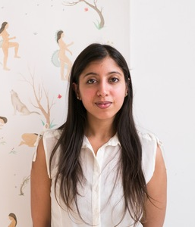
Hiba Schahbaz trained in the art of miniature painting at the National College of Arts in Lahore, Pakistan. She has practiced contemporary miniature painting for the past 10 years and recently received her MFA in Painting from Pratt Institute in Brooklyn, NY. She has exhibited her work in miniature painting internationally, in addition to curating exhibitions of miniature paintings in Pakistan and India.

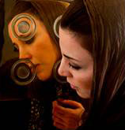
Atoosa Vahdani began her practice as a student in Tehran’s Kargah-Honar Workshop in 1994, continuing on to become a professor of sculpture in the same location. In 2006, Vahdani was introduced to Parviz Tanavoli, master of Iranian sculpture known for his formative influence on Iran’s modern art movements in the 1960s and ‘70s. Apprenticing under Tanavoli between 2006 and 2009, Vahdani was introduced to a range of formal techniques that continue to inform her practice.

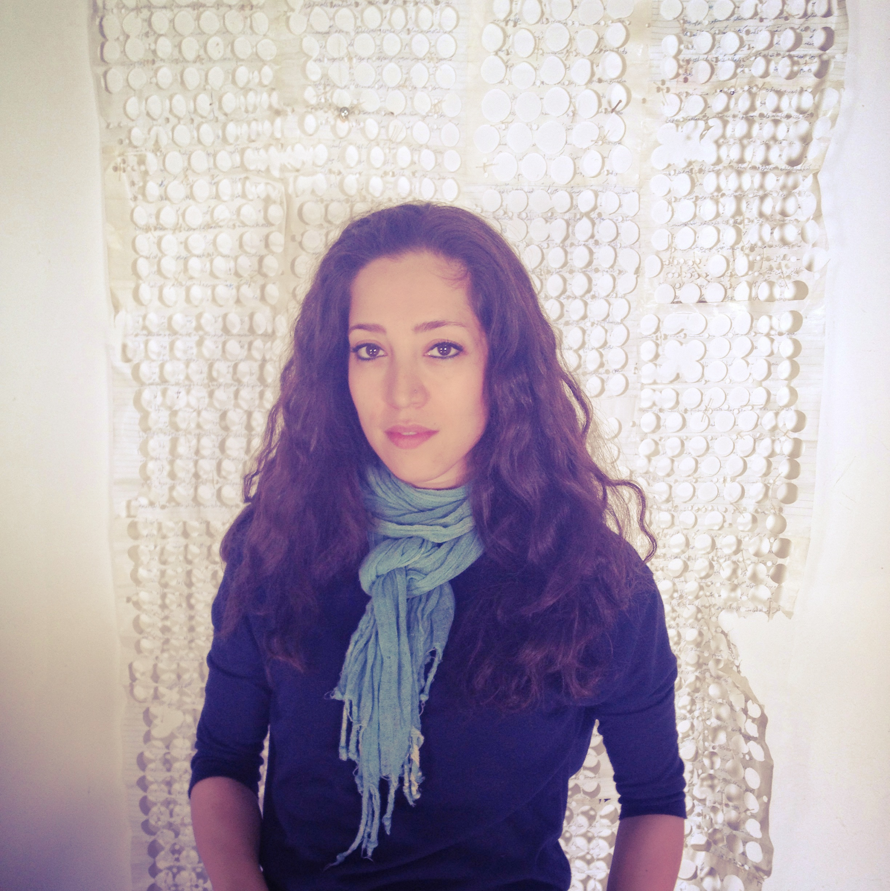
Shadi Yousefian is a contemporary photographer and mixed-media artist whose work investigates issues of transnational identity and cross-cultural belonging at a personal and social scale. She conveys her experience emigrating from Iran to the United States at the age of 16 while reflecting upon commonalities among immigrant experiences around the world. Yousefian received a BFA (2003) and a MFA (2006) from San Francisco State University. In 2005, she was offered a Murphy & Cadogan Fellowship in the Arts for her exhibition in the San Francisco Arts Commission Gallery. In 2004 and 2005, she received International Photo Awards from the Lucie Foundation. She has exhibited widely in California, with past shows including “East of the West,” SOMArts Gallery; “Theory of Survival,” The Lab; “Celluloid: Film & Photography Exhibition,” Gallery One.

